Moments Text Effects API

# Description

The SteelSeries Moments team recently added a new feature to Moments that allows users to overlay text on their clipped videos. We call this feature “Text Effects”. Under the hood, Moments is using an amazing piece of open-source software called FFmpeg (<https://ffmpeg.org/>) to overlay text on top of videos.

### Screenshot

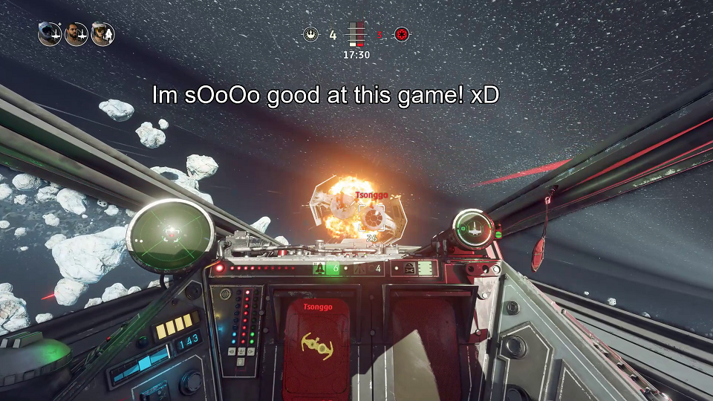

To implement this feature, the team created an API to translate a text effect created in the front end to a command string that FFmpeg can digest. So the question is, how would *you* build an API to solve this problem? We would like you to **create a *back end* program with an HTTP API that can translate the parameters of a text effect created in the front end (i.e. text string, X/Y position, etc.) to a command string that FFmpeg can digest**.

# Requirements

* Please use the programming language you are most comfortable with out of the following: C/C++, C#, Go, Java, JavaScript, Python, TypeScript.
* You do not need to create a front end. In addition to returning HTTP responses, your program may also choose to log responses to the console.
* You are not expected to know, or learn, how FFmpeg works. All the sample input data and resulting FFmpeg output data that your app needs to handle is listed in the *Test Input / Output* section.
* Your program does not need to actually call FFmpeg. It only needs to provide a valid output string that would be passed into it, or an error.
* Please include a short README explaining how to build and/or run your program, and if you were unable to get any of the test cases to pass.

# Design Considerations

In the follow-up interview, please be prepared to discuss your design decisions. Some follow-up questions may include:

* How would you test this feature?
* What changes would you need to make to support adding *video* overlays instead of *text* overlays?

# Test Input / Output

## Assumptions

* The front end already knows about the *file path*, *duration*, and *resolution* of each video. You do not need to create an API for the front end to query them from your back end.
* Don’t worry about escaping quote characters (e.g. ‘ or “) in the *text* field of the FFmpeg command string.

## Test #1

### Test Video:

|  |  |
| --- | --- |
| Input video path | test_input1.mp4 |
| Duration | 60.0 s |
| Resolution | 1920 x 1080 |
| Output video path | test_output1.mp4 |

### Text Effect:

|  |  |
| --- | --- |
| Text String | “I’m sOoOo good at this game! xD” |
| X, Y | 200, 100 |
| Font Size | 64 |
| Font Color | 0xFFFFFF |
| Start Time | 23.0 s |
| End Time | 40.0 s |

### Expected Output:

**SUCCESS**

**FFmpeg command string:** ffmpeg -i test_input1.mp4 -vf \

drawtext="enable='between(t,23.0,40.0)': \

text='I’m sOoOo good at this game! xD':fontcolor=0xFFFFFF:fontsize=64: \

x=200:y=100" test_output1.mp4

## Test #2

### Test Video:

|  |  |
| --- | --- |
| Input video path | test_input2.mp4 |
| Duration | 60.0 s |
| Resolution | 1920 x 1080 |
| Output video path | test_output2.mp4 |

### Text Effect:

|  |  |
| --- | --- |
| Text String | “Brutal, Savage, Rekt” |
| X, Y | 0, 0 |
| Font Size | 48 |
| Font Color | 0x000000 |
| Start Time | 0.0 s |
| End Time | 60.0 s |

### Expected Output:

**SUCCESS**

**FFmpeg command string:** ffmpeg -i test_input2.mp4 -vf \

drawtext="enable='between(t,0.0,60.0)':text='Brutal, Savage, \

Rekt':fontcolor=0x000000:fontsize=48:x=0:y=0" test_output2.mp4

## Test #3

### Test Video:

|  |  |
| --- | --- |
| Input video path | test_input3.mp4 |
| Duration | 60.0 s |
| Resolution | 1920 x 1080 |
| Output video path | test_output3.mp4 |

### Text Effect:

|  |  |
| --- | --- |
| Text String | “RIP” |
| X, Y | 100, 200 |
| Font Size | 32 |
| Font Color | 0xFFFFFF |
| Start Time | 24.0 s |
| End Time | 75.0 s |

### Expected Output:

**ERROR**

Error string: Invalid End Time

## Test #4

### Test Video:

|  |  |
| --- | --- |
| Input video path | test_input4.mp4 |
| Duration | 60.0 s |
| Resolution | 1920 x 1080 |
| Output video path | test_output4.mp4 |

### Text Effect:

|  |  |
| --- | --- |
| Text String | “RIP” |
| X, Y | 100, 9999 |
| Font Size | 48 |
| Font Color | 0x777777 |
| Start Time | 24.0 s |
| End Time | 48.0 s |

### Expected Output:

**ERROR**

Error string: Invalid X,Y coordinate